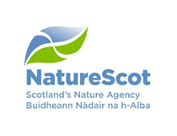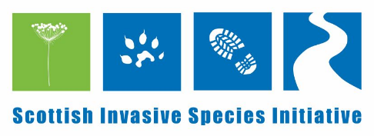
Role: Seasonal Project Officer (Scottish Invasive Species Initiative)
Key tasks and responsibilities
The Seasonal Project Officer will work closely with the Project Officer and Volunteer and Communication Officer to undertake the following tasks:
- Work with the Project Officer to deliver a practical work programme for volunteers.
- Working with local land-managers, ghillies, gamekeepers, communities, volunteers and other stakeholders, recruit, coordinate and maintain a network of volunteers and wildlife management professionals.
- With the Project Officer liaise, motivate and communicate with volunteers as required.
- Organise and where required lead volunteer work parties for the clearance of invasive non-native plants.
- Be responsible for all logistics associated with the deployment and workings of volunteer work parties.
- Ensure that all Health and Safety requirements are met and protocols are followed.
- Record volunteer tasks undertaken and time spent.
- Record the extent and abundance of plants within target populations treated by volunteers.
- With the Project Officer maintain a surveillance network to record the occurrence of target invasive species.
- Provide training to the volunteer network as required that includes but is not limited to:
  - The set-up, maintenance and running of mink rafts.
  - Humane dispatch of mink (where appropriate).
  - Identification skills for key native species and non-native plants.
  - Data collection according to standardised protocols.
- Monitor the outcomes and impacts of the control work undertaken.
Experience and skills
- Well motivated to undertake tasks in liaison with other Project staff
- Physically fit to carry out manual clearance of invasive non-native plants
- Ability to demonstrate experience of leading volunteer groups
- Good record keeping skills
- Good communication skills and a proven ability to deliver projects with supervision
- Advantageous to hold City & Guilds NPTC Level 2 Award in PA1 (safe use of pesticides), PA6 (hand held applicator) and W (for use by water) qualification
- Advantageous to hold First Aid at Work or Outdoor First Aid qualification
- A full driving licence and access to a vehicle for work is essential

